1 run......

Downloading: 100%

464/464 [00:00<00:00, 17.1kB/s]

Downloading: 100%

270M/270M [00:12<00:00, 23.6MB/s]

training 1 epoch...

9.892874717712402 seconds used......

1 training finished! average train loss: 1.0526743680238724

total clf loss: 39.129203617572784 total adv loss: 24.65852463245392

evaluating...

Confusion matrix, without normalization

[[ 0 40 1]

[ 0 91 4]

[ 0 506 208]]

Normalized confusion matrix

[[0. 0.97560976 0.02439024]

[0. 0.95789474 0.04210526]

[0. 0.70868347 0.29131653]]

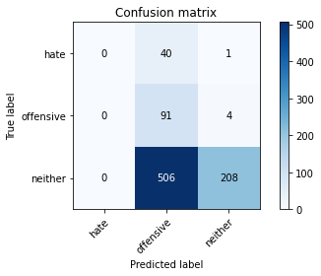

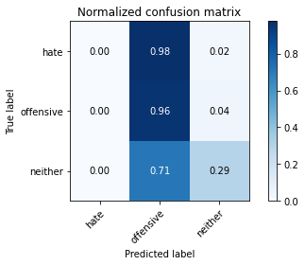

/opt/conda/lib/python3.7/site-packages/sklearn/metrics/_classification.py:1245: UndefinedMetricWarning: Precision and F-score are ill-defined and being set to 0.0 in labels with no predicted samples. Use `zero_division` parameter to control this behavior.

_warn_prf(average, modifier, msg_start, len(result))

/opt/conda/lib/python3.7/site-packages/sklearn/metrics/_classification.py:1245: UndefinedMetricWarning: Precision and F-score are ill-defined and being set to 0.0 in labels with no predicted samples. Use `zero_division` parameter to control this behavior.

_warn_prf(average, modifier, msg_start, len(result))

/opt/conda/lib/python3.7/site-packages/sklearn/metrics/_classification.py:1245: UndefinedMetricWarning: Precision and F-score are ill-defined and being set to 0.0 in labels with no predicted samples. Use `zero_division` parameter to control this behavior.

_warn_prf(average, modifier, msg_start, len(result))

precision recall f1-score support

hate 0.00 0.00 0.00 41

offensive 0.14 0.96 0.25 95

neither 0.98 0.29 0.45 714

accuracy 0.35 850

macro avg 0.37 0.42 0.23 850

weighted avg 0.84 0.35 0.40 850

average eval_loss: 0.9973318479781927, accuracy: 0.3517647058823529

training 2 epoch...

8.963623523712158 seconds used......

2 training finished! average train loss: 0.9022078100177977

total clf loss: 33.55707895755768 total adv loss: 21.551952332258224

evaluating...

Confusion matrix, without normalization

[[ 0 37 4]

[ 0 80 15]

[ 0 303 411]]

Normalized confusion matrix

[[0. 0.90243902 0.09756098]

[0. 0.84210526 0.15789474]

[0. 0.42436975 0.57563025]]

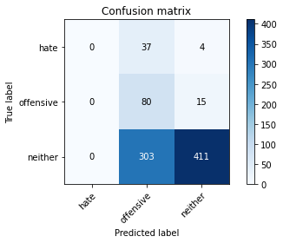

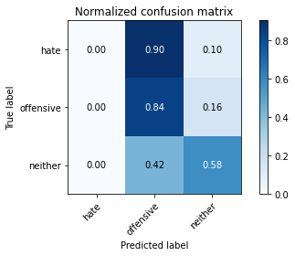

/opt/conda/lib/python3.7/site-packages/sklearn/metrics/_classification.py:1245: UndefinedMetricWarning: Precision and F-score are ill-defined and being set to 0.0 in labels with no predicted samples. Use `zero_division` parameter to control this behavior.

_warn_prf(average, modifier, msg_start, len(result))

/opt/conda/lib/python3.7/site-packages/sklearn/metrics/_classification.py:1245: UndefinedMetricWarning: Precision and F-score are ill-defined and being set to 0.0 in labels with no predicted samples. Use `zero_division` parameter to control this behavior.

_warn_prf(average, modifier, msg_start, len(result))

/opt/conda/lib/python3.7/site-packages/sklearn/metrics/_classification.py:1245: UndefinedMetricWarning: Precision and F-score are ill-defined and being set to 0.0 in labels with no predicted samples. Use `zero_division` parameter to control this behavior.

_warn_prf(average, modifier, msg_start, len(result))

precision recall f1-score support

hate 0.00 0.00 0.00 41

offensive 0.19 0.84 0.31 95

neither 0.96 0.58 0.72 714

accuracy 0.58 850

macro avg 0.38 0.47 0.34 850

weighted avg 0.82 0.58 0.64 850

average eval_loss: 0.8721845662871073, accuracy: 0.5776470588235294

training 3 epoch...

8.91243600845337 seconds used......

3 training finished! average train loss: 0.7689936972326703

total clf loss: 28.608758568763733 total adv loss: 18.499707758426666

evaluating...

Confusion matrix, without normalization

[[ 14 5 22]

[ 6 12 77]

[ 41 47 626]]

Normalized confusion matrix

[[0.34146341 0.12195122 0.53658537]

[0.06315789 0.12631579 0.81052632]

[0.05742297 0.06582633 0.8767507 ]]

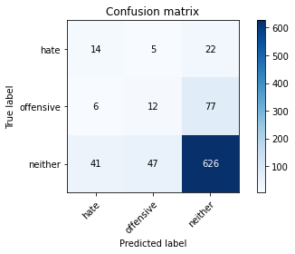

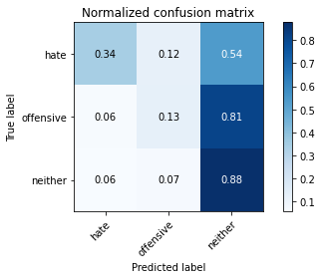

precision recall f1-score support

hate 0.23 0.34 0.27 41

offensive 0.19 0.13 0.15 95

neither 0.86 0.88 0.87 714

accuracy 0.77 850

macro avg 0.43 0.45 0.43 850

weighted avg 0.76 0.77 0.76 850

average eval_loss: 0.6893290154809175, accuracy: 0.7670588235294118

training 4 epoch...

8.97974681854248 seconds used......

4 training finished! average train loss: 0.6417230144143105

total clf loss: 24.101573258638382 total adv loss: 19.990893185138702

evaluating...

Confusion matrix, without normalization

[[ 2 22 17]

[ 1 52 42]

[ 8 175 531]]

Normalized confusion matrix

[[0.04878049 0.53658537 0.41463415]

[0.01052632 0.54736842 0.44210526]

[0.01120448 0.24509804 0.74369748]]

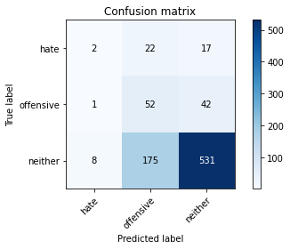

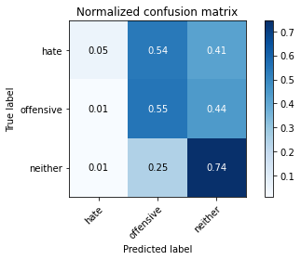

precision recall f1-score support

hate 0.18 0.05 0.08 41

offensive 0.21 0.55 0.30 95

neither 0.90 0.74 0.81 714

accuracy 0.69 850

macro avg 0.43 0.45 0.40 850

weighted avg 0.79 0.69 0.72 850

average eval_loss: 0.7232110715189646, accuracy: 0.6882352941176471

training 5 epoch...

8.920920848846436 seconds used......

5 training finished! average train loss: 0.43164246694909203

total clf loss: 16.075653642416 total adv loss: 10.730495125055313

evaluating...

Confusion matrix, without normalization

[[ 18 9 14]

[ 20 52 23]

[ 99 115 500]]

Normalized confusion matrix

[[0.43902439 0.2195122 0.34146341]

[0.21052632 0.54736842 0.24210526]

[0.13865546 0.16106443 0.70028011]]

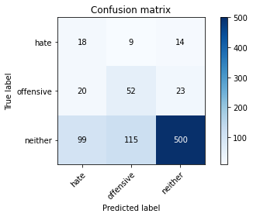

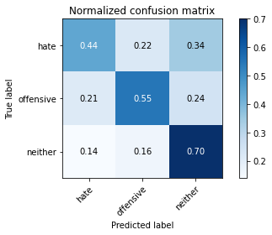

precision recall f1-score support

hate 0.13 0.44 0.20 41

offensive 0.30 0.55 0.38 95

neither 0.93 0.70 0.80 714

accuracy 0.67 850

macro avg 0.45 0.56 0.46 850

weighted avg 0.82 0.67 0.72 850

average eval_loss: 0.7949702540455863, accuracy: 0.6705882352941176

training 6 epoch...

8.945297718048096 seconds used......

6 training finished! average train loss: 0.24237364851352242

total clf loss: 9.004498248919845 total adv loss: 5.580937668215483

evaluating...

Confusion matrix, without normalization

[[ 10 17 14]

[ 9 62 24]

[ 62 180 472]]

Normalized confusion matrix

[[0.24390244 0.41463415 0.34146341]

[0.09473684 0.65263158 0.25263158]

[0.08683473 0.25210084 0.66106443]]

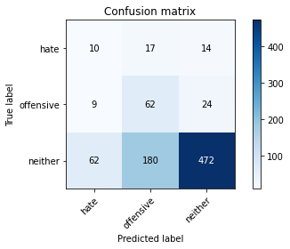

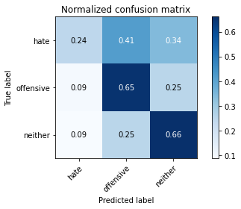

precision recall f1-score support

hate 0.12 0.24 0.16 41

offensive 0.24 0.65 0.35 95

neither 0.93 0.66 0.77 714

accuracy 0.64 850

macro avg 0.43 0.52 0.43 850

weighted avg 0.81 0.64 0.69 850

average eval_loss: 0.9080987304968889, accuracy: 0.64

training 7 epoch...

8.941482305526733 seconds used......

7 training finished! average train loss: 0.11637026847650607

total clf loss: 4.3246998228132725 total adv loss: 2.7074030926451087

evaluating...

Confusion matrix, without normalization

[[ 10 17 14]

[ 7 64 24]

[ 53 172 489]]

Normalized confusion matrix

[[0.24390244 0.41463415 0.34146341]

[0.07368421 0.67368421 0.25263158]

[0.07422969 0.24089636 0.68487395]]

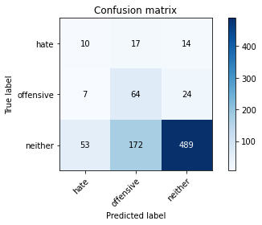

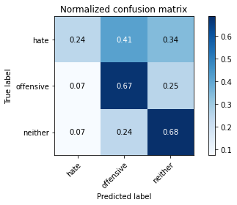

precision recall f1-score support

hate 0.14 0.24 0.18 41

offensive 0.25 0.67 0.37 95

neither 0.93 0.68 0.79 714

accuracy 0.66 850

macro avg 0.44 0.53 0.45 850

weighted avg 0.81 0.66 0.71 850

average eval_loss: 1.010979573329001, accuracy: 0.6623529411764706

training 8 epoch...

8.941726207733154 seconds used......

8 training finished! average train loss: 0.05819438894589742

total clf loss: 2.1749343127012253 total adv loss: 1.598726192722097

evaluating...

Confusion matrix, without normalization

[[ 9 24 8]

[ 10 74 11]

[ 83 236 395]]

Normalized confusion matrix

[[0.2195122 0.58536585 0.19512195]

[0.10526316 0.77894737 0.11578947]

[0.1162465 0.33053221 0.55322129]]

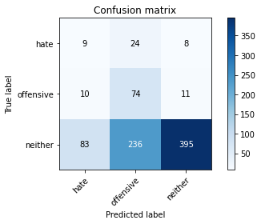

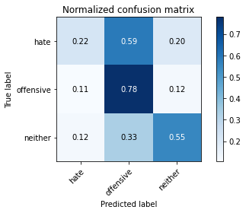

precision recall f1-score support

hate 0.09 0.22 0.13 41

offensive 0.22 0.78 0.34 95

neither 0.95 0.55 0.70 714

accuracy 0.56 850

macro avg 0.42 0.52 0.39 850

weighted avg 0.83 0.56 0.63 850

average eval_loss: 1.5615846757278886, accuracy: 0.5623529411764706

training 9 epoch...

8.969152927398682 seconds used......

9 training finished! average train loss: 0.019789763338242967

total clf loss: 0.72752386610955 total adv loss: 0.3018477451405488

evaluating...

Confusion matrix, without normalization

[[ 9 17 15]

[ 8 55 32]

[ 52 143 519]]

Normalized confusion matrix

[[0.2195122 0.41463415 0.36585366]

[0.08421053 0.57894737 0.33684211]

[0.07282913 0.20028011 0.72689076]]

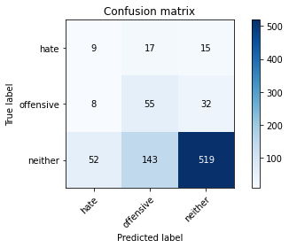

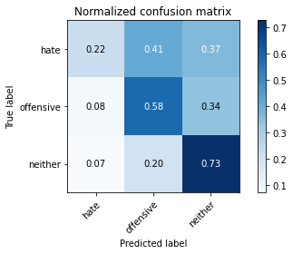

precision recall f1-score support

hate 0.13 0.22 0.16 41

offensive 0.26 0.58 0.35 95

neither 0.92 0.73 0.81 714

accuracy 0.69 850

macro avg 0.43 0.51 0.44 850

weighted avg 0.81 0.69 0.73 850

average eval_loss: 1.0522942979776755, accuracy: 0.6858823529411765

training 10 epoch...

8.979146242141724 seconds used......

10 training finished! average train loss: 0.010774938538411839

total clf loss: 0.3916335850954056 total adv loss: 0.07471601979341358

evaluating...

Confusion matrix, without normalization

[[ 10 16 15]

[ 7 61 27]

[ 58 166 490]]

Normalized confusion matrix

[[0.24390244 0.3902439 0.36585366]

[0.07368421 0.64210526 0.28421053]

[0.08123249 0.232493 0.68627451]]

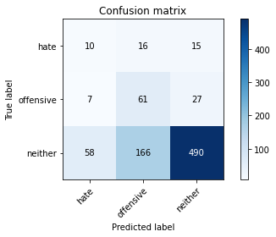

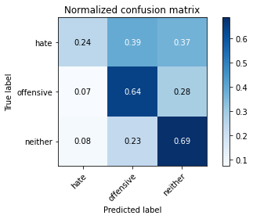

precision recall f1-score support

hate 0.13 0.24 0.17 41

offensive 0.25 0.64 0.36 95

neither 0.92 0.69 0.79 714

accuracy 0.66 850

macro avg 0.44 0.52 0.44 850

weighted avg 0.81 0.66 0.71 850

average eval_loss: 1.2292878328021182, accuracy: 0.66

2 run......

training 1 epoch...

8.938335418701172 seconds used......

1 training finished! average train loss: 1.0527003109455109

total clf loss: 39.06713259220123 total adv loss: 23.39842712879181

evaluating...

Confusion matrix, without normalization

[[ 0 37 4]

[ 0 73 22]

[ 0 319 395]]

Normalized confusion matrix

[[0. 0.90243902 0.09756098]

[0. 0.76842105 0.23157895]

[0. 0.44677871 0.55322129]]

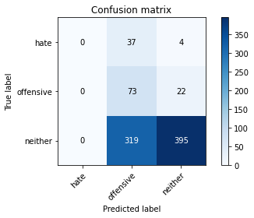

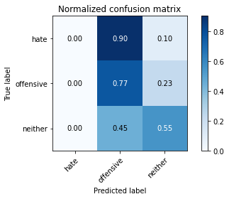

/opt/conda/lib/python3.7/site-packages/sklearn/metrics/_classification.py:1245: UndefinedMetricWarning: Precision and F-score are ill-defined and being set to 0.0 in labels with no predicted samples. Use `zero_division` parameter to control this behavior.

_warn_prf(average, modifier, msg_start, len(result))

/opt/conda/lib/python3.7/site-packages/sklearn/metrics/_classification.py:1245: UndefinedMetricWarning: Precision and F-score are ill-defined and being set to 0.0 in labels with no predicted samples. Use `zero_division` parameter to control this behavior.

_warn_prf(average, modifier, msg_start, len(result))

/opt/conda/lib/python3.7/site-packages/sklearn/metrics/_classification.py:1245: UndefinedMetricWarning: Precision and F-score are ill-defined and being set to 0.0 in labels with no predicted samples. Use `zero_division` parameter to control this behavior.

_warn_prf(average, modifier, msg_start, len(result))

precision recall f1-score support

hate 0.00 0.00 0.00 41

offensive 0.17 0.77 0.28 95

neither 0.94 0.55 0.70 714

accuracy 0.55 850

macro avg 0.37 0.44 0.32 850

weighted avg 0.81 0.55 0.62 850

average eval_loss: 0.9443550497986549, accuracy: 0.5505882352941176

training 2 epoch...

8.933947324752808 seconds used......

2 training finished! average train loss: 0.8973488377200233

total clf loss: 33.44960379600525 total adv loss: 22.900908589363098

evaluating...

Confusion matrix, without normalization

[[ 1 39 1]

[ 3 88 4]

[ 37 400 277]]

Normalized confusion matrix

[[0.02439024 0.95121951 0.02439024]

[0.03157895 0.92631579 0.04210526]

[0.05182073 0.56022409 0.38795518]]

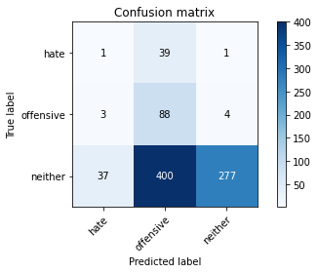

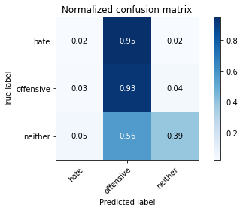

precision recall f1-score support

hate 0.02 0.02 0.02 41

offensive 0.17 0.93 0.28 95

neither 0.98 0.39 0.56 714

accuracy 0.43 850

macro avg 0.39 0.45 0.29 850

weighted avg 0.84 0.43 0.50 850

average eval_loss: 1.0281573475100274, accuracy: 0.43058823529411766

training 3 epoch...

8.935437440872192 seconds used......

3 training finished! average train loss: 0.7294387999508116

total clf loss: 27.208122104406357 total adv loss: 18.966505900025368

evaluating...

Confusion matrix, without normalization

[[ 13 21 7]

[ 13 74 8]

[106 223 385]]

Normalized confusion matrix

[[0.31707317 0.51219512 0.17073171]

[0.13684211 0.77894737 0.08421053]

[0.14845938 0.31232493 0.53921569]]

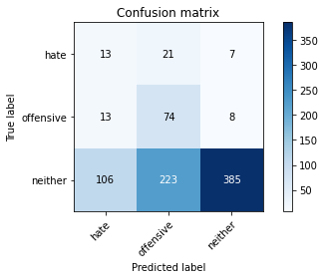

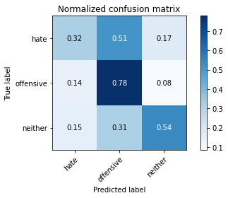

precision recall f1-score support

hate 0.10 0.32 0.15 41

offensive 0.23 0.78 0.36 95

neither 0.96 0.54 0.69 714

accuracy 0.56 850

macro avg 0.43 0.55 0.40 850

weighted avg 0.84 0.56 0.63 850

average eval_loss: 0.9025696976933368, accuracy: 0.5552941176470588

training 4 epoch...

8.966859579086304 seconds used......

4 training finished! average train loss: 0.5670031963123215

total clf loss: 21.1060751080513 total adv loss: 13.879203051328659

evaluating...

Confusion matrix, without normalization

[[ 10 17 14]

[ 10 57 28]

[ 45 131 538]]

Normalized confusion matrix

[[0.24390244 0.41463415 0.34146341]

[0.10526316 0.6 0.29473684]

[0.06302521 0.18347339 0.7535014 ]]

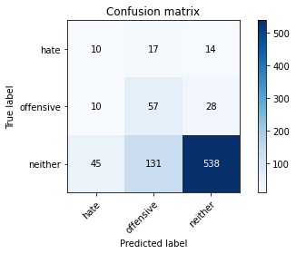

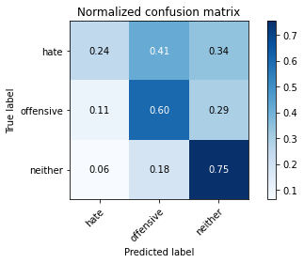

precision recall f1-score support

hate 0.15 0.24 0.19 41

offensive 0.28 0.60 0.38 95

neither 0.93 0.75 0.83 714

accuracy 0.71 850

macro avg 0.45 0.53 0.47 850

weighted avg 0.82 0.71 0.75 850

average eval_loss: 0.6808321887497292, accuracy: 0.711764705882353

training 5 epoch...

8.935089111328125 seconds used......

5 training finished! average train loss: 0.3610924945937263

total clf loss: 13.44252522289753 total adv loss: 8.863909516483545

evaluating...

Confusion matrix, without normalization

[[ 17 17 7]

[ 16 69 10]

[127 173 414]]

Normalized confusion matrix

[[0.41463415 0.41463415 0.17073171]

[0.16842105 0.72631579 0.10526316]

[0.17787115 0.24229692 0.57983193]]

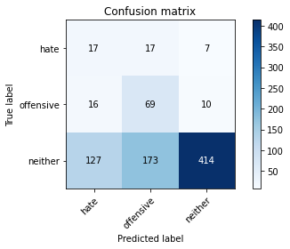

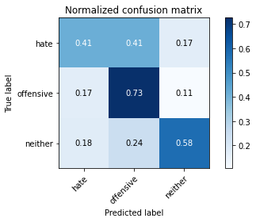

precision recall f1-score support

hate 0.11 0.41 0.17 41

offensive 0.27 0.73 0.39 95

neither 0.96 0.58 0.72 714

accuracy 0.59 850

macro avg 0.44 0.57 0.43 850

weighted avg 0.84 0.59 0.66 850

average eval_loss: 0.9910169553964637, accuracy: 0.5882352941176471

training 6 epoch...

8.92061161994934 seconds used......

6 training finished! average train loss: 0.1942165551914109

total clf loss: 7.155724182724953 total adv loss: 3.2785647724522278

evaluating...

Confusion matrix, without normalization

[[ 21 14 6]

[ 23 66 6]

[160 219 335]]

Normalized confusion matrix

[[0.51219512 0.34146341 0.14634146]

[0.24210526 0.69473684 0.06315789]

[0.22408964 0.30672269 0.46918768]]

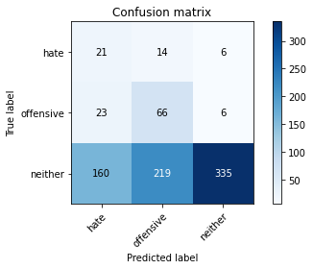

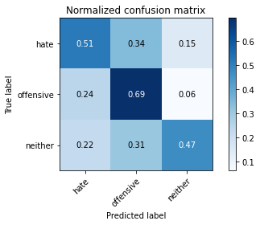

precision recall f1-score support

hate 0.10 0.51 0.17 41

offensive 0.22 0.69 0.34 95

neither 0.97 0.47 0.63 714

accuracy 0.50 850

macro avg 0.43 0.56 0.38 850

weighted avg 0.84 0.50 0.58 850

average eval_loss: 1.4532022670257922, accuracy: 0.4964705882352941

training 7 epoch...

8.916659832000732 seconds used......

7 training finished! average train loss: 0.07741447957232594

total clf loss: 2.822700722143054 total adv loss: 0.7155897315824404

evaluating...

Confusion matrix, without normalization

[[ 13 17 11]

[ 11 66 18]

[ 66 147 501]]

Normalized confusion matrix

[[0.31707317 0.41463415 0.26829268]

[0.11578947 0.69473684 0.18947368]

[0.09243697 0.20588235 0.70168067]]

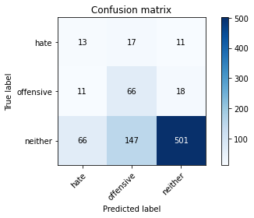

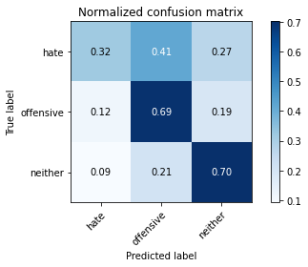

precision recall f1-score support

hate 0.14 0.32 0.20 41

offensive 0.29 0.69 0.41 95

neither 0.95 0.70 0.81 714

accuracy 0.68 850

macro avg 0.46 0.57 0.47 850

weighted avg 0.83 0.68 0.73 850

average eval_loss: 0.9599344238292339, accuracy: 0.6823529411764706

training 8 epoch...

8.957995653152466 seconds used......

8 training finished! average train loss: 0.034975102378262415

total clf loss: 1.2843706980347633 total adv loss: 0.5053403812053148

evaluating...

Confusion matrix, without normalization

[[ 10 21 10]

[ 8 76 11]

[ 71 197 446]]

Normalized confusion matrix

[[0.24390244 0.51219512 0.24390244]

[0.08421053 0.8 0.11578947]

[0.09943978 0.27591036 0.62464986]]

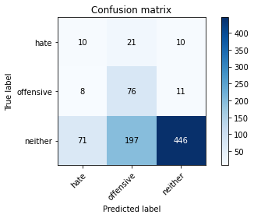

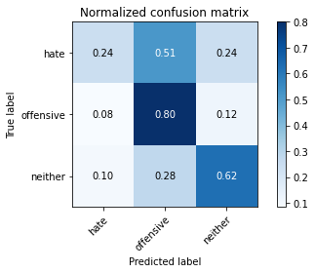

precision recall f1-score support

hate 0.11 0.24 0.15 41

offensive 0.26 0.80 0.39 95

neither 0.96 0.62 0.76 714

accuracy 0.63 850

macro avg 0.44 0.56 0.43 850

weighted avg 0.84 0.63 0.69 850

average eval_loss: 1.274579592287367, accuracy: 0.6258823529411764

training 9 epoch...

9.006057024002075 seconds used......

9 training finished! average train loss: 0.018628939624047942

total clf loss: 0.6861001050565392 total adv loss: 0.3091656321485061

evaluating...

Confusion matrix, without normalization

[[ 9 19 13]

[ 4 69 22]

[ 59 184 471]]

Normalized confusion matrix

[[0.2195122 0.46341463 0.31707317]

[0.04210526 0.72631579 0.23157895]

[0.08263305 0.25770308 0.65966387]]

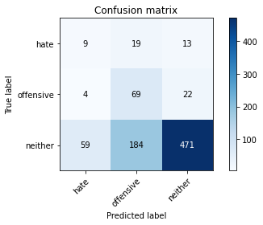

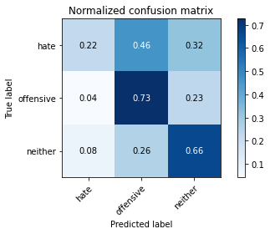

precision recall f1-score support

hate 0.12 0.22 0.16 41

offensive 0.25 0.73 0.38 95

neither 0.93 0.66 0.77 714

accuracy 0.65 850

macro avg 0.44 0.54 0.44 850

weighted avg 0.82 0.65 0.70 850

average eval_loss: 1.2135818159792486, accuracy: 0.6458823529411765

training 10 epoch...

8.928030252456665 seconds used......

10 training finished! average train loss: 0.012813826473171098

total clf loss: 0.4737284502480179 total adv loss: 0.24861393215542194

evaluating...

Confusion matrix, without normalization

[[ 8 23 10]

[ 4 79 12]

[ 60 211 443]]

Normalized confusion matrix

[[0.19512195 0.56097561 0.24390244]

[0.04210526 0.83157895 0.12631579]

[0.08403361 0.29551821 0.62044818]]

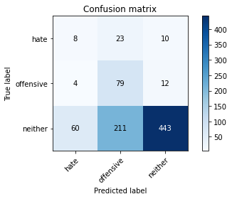

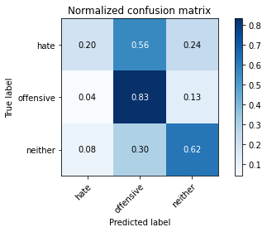

precision recall f1-score support

hate 0.11 0.20 0.14 41

offensive 0.25 0.83 0.39 95

neither 0.95 0.62 0.75 714

accuracy 0.62 850

macro avg 0.44 0.55 0.43 850

weighted avg 0.83 0.62 0.68 850

average eval_loss: 1.362399420885066, accuracy: 0.6235294117647059

3 run......

training 1 epoch...

8.955925226211548 seconds used......

1 training finished! average train loss: 1.0402019288804796

total clf loss: 38.62700241804123 total adv loss: 23.594663053750992

evaluating...

Confusion matrix, without normalization

[[ 1 39 1]

[ 0 87 8]

[ 6 470 238]]

Normalized confusion matrix

[[0.02439024 0.95121951 0.02439024]

[0. 0.91578947 0.08421053]

[0.00840336 0.65826331 0.33333333]]

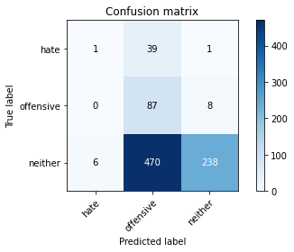

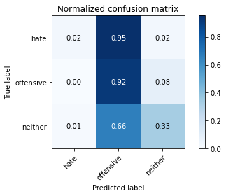

precision recall f1-score support

hate 0.14 0.02 0.04 41

offensive 0.15 0.92 0.25 95

neither 0.96 0.33 0.50 714

accuracy 0.38 850

macro avg 0.42 0.42 0.26 850

weighted avg 0.83 0.38 0.45 850

average eval_loss: 1.0357263767442038, accuracy: 0.3835294117647059

training 2 epoch...

8.922852993011475 seconds used......

2 training finished! average train loss: 0.8851455499728521

total clf loss: 32.90874856710434 total adv loss: 20.870175033807755

evaluating...

Confusion matrix, without normalization

[[ 5 22 14]

[ 0 42 53]

[ 4 137 573]]

Normalized confusion matrix

[[0.12195122 0.53658537 0.34146341]

[0. 0.44210526 0.55789474]

[0.00560224 0.19187675 0.80252101]]

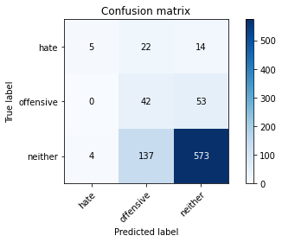

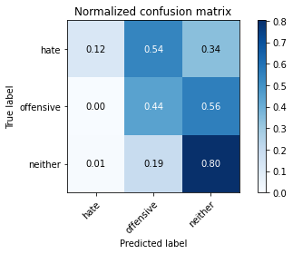

precision recall f1-score support

hate 0.56 0.12 0.20 41

offensive 0.21 0.44 0.28 95

neither 0.90 0.80 0.85 714

accuracy 0.73 850

macro avg 0.55 0.46 0.44 850

weighted avg 0.80 0.73 0.75 850

average eval_loss: 0.7243717004393422, accuracy: 0.7294117647058823

training 3 epoch...

8.931657791137695 seconds used......

3 training finished! average train loss: 0.7644067274199592

total clf loss: 28.52948397397995 total adv loss: 20.216836780309677

evaluating...

Confusion matrix, without normalization

[[ 12 22 7]

[ 8 69 18]

[ 77 194 443]]

Normalized confusion matrix

[[0.29268293 0.53658537 0.17073171]

[0.08421053 0.72631579 0.18947368]

[0.10784314 0.27170868 0.62044818]]

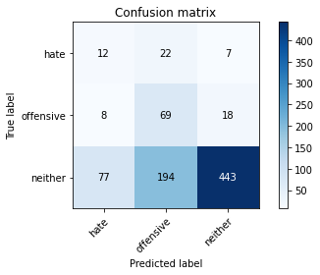

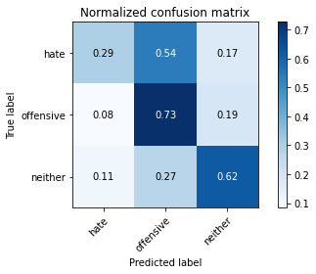

precision recall f1-score support

hate 0.12 0.29 0.17 41

offensive 0.24 0.73 0.36 95

neither 0.95 0.62 0.75 714

accuracy 0.62 850

macro avg 0.44 0.55 0.43 850

weighted avg 0.83 0.62 0.68 850

average eval_loss: 0.8694604546871296, accuracy: 0.6164705882352941

training 4 epoch...

8.984484910964966 seconds used......

4 training finished! average train loss: 0.6084747885664304

total clf loss: 22.69439709186554 total adv loss: 15.78609624505043

evaluating...

Confusion matrix, without normalization

[[ 7 17 17]

[ 2 49 44]

[ 22 122 570]]

Normalized confusion matrix

[[0.17073171 0.41463415 0.41463415]

[0.02105263 0.51578947 0.46315789]

[0.03081232 0.17086835 0.79831933]]

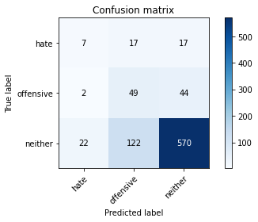

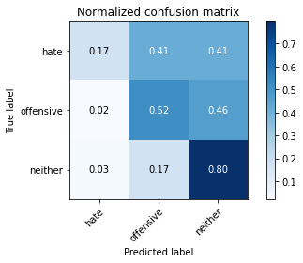

precision recall f1-score support

hate 0.23 0.17 0.19 41

offensive 0.26 0.52 0.35 95

neither 0.90 0.80 0.85 714

accuracy 0.74 850

macro avg 0.46 0.49 0.46 850

weighted avg 0.80 0.74 0.76 850

average eval_loss: 0.6473902630251508, accuracy: 0.7364705882352941

training 5 epoch...

8.92265272140503 seconds used......

5 training finished! average train loss: 0.4175223840607537

total clf loss: 15.499762371182442 total adv loss: 9.379130072891712

evaluating...

Confusion matrix, without normalization

[[ 14 15 12]

[ 5 66 24]

[ 49 159 506]]

Normalized confusion matrix

[[0.34146341 0.36585366 0.29268293]

[0.05263158 0.69473684 0.25263158]

[0.06862745 0.22268908 0.70868347]]

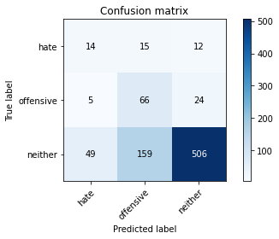

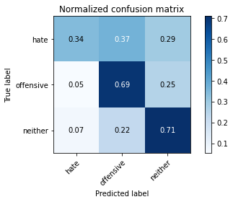

precision recall f1-score support

hate 0.21 0.34 0.26 41

offensive 0.28 0.69 0.39 95

neither 0.93 0.71 0.81 714

accuracy 0.69 850

macro avg 0.47 0.58 0.49 850

weighted avg 0.82 0.69 0.73 850

average eval_loss: 0.7565402116539867, accuracy: 0.6894117647058824

training 6 epoch...

8.952163696289062 seconds used......

6 training finished! average train loss: 0.222276426696529

total clf loss: 8.223713282495737 total adv loss: 4.435238652862608

evaluating...

Confusion matrix, without normalization

[[ 13 19 9]

[ 10 67 18]

[ 74 192 448]]

Normalized confusion matrix

[[0.31707317 0.46341463 0.2195122 ]

[0.10526316 0.70526316 0.18947368]

[0.10364146 0.26890756 0.62745098]]

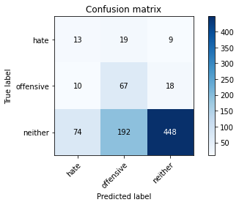

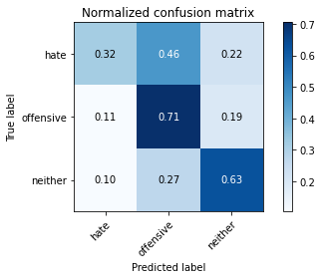

precision recall f1-score support

hate 0.13 0.32 0.19 41

offensive 0.24 0.71 0.36 95

neither 0.94 0.63 0.75 714

accuracy 0.62 850

macro avg 0.44 0.55 0.43 850

weighted avg 0.83 0.62 0.68 850

average eval_loss: 1.0893174259122027, accuracy: 0.6211764705882353

training 7 epoch...

8.948636054992676 seconds used......

7 training finished! average train loss: 0.0977387936371896

total clf loss: 3.5871763974428177 total adv loss: 1.3715968097094446

evaluating...

Confusion matrix, without normalization

[[ 13 16 12]

[ 10 61 24]

[ 67 155 492]]

Normalized confusion matrix

[[0.31707317 0.3902439 0.29268293]

[0.10526316 0.64210526 0.25263158]

[0.09383754 0.21708683 0.68907563]]

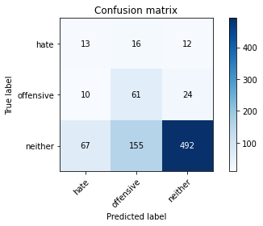

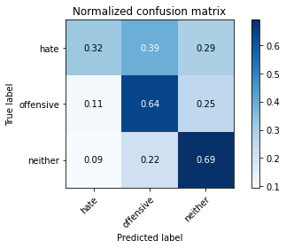

precision recall f1-score support

hate 0.14 0.32 0.20 41

offensive 0.26 0.64 0.37 95

neither 0.93 0.69 0.79 714

accuracy 0.67 850

macro avg 0.45 0.55 0.45 850

weighted avg 0.82 0.67 0.72 850

average eval_loss: 1.042228010288158, accuracy: 0.6658823529411765

training 8 epoch...

8.914721250534058 seconds used......

8 training finished! average train loss: 0.04025140490072469

total clf loss: 1.4709771946072578 total adv loss: 0.4385321699664928

evaluating...

Confusion matrix, without normalization

[[ 14 17 10]

[ 12 68 15]

[ 82 203 429]]

Normalized confusion matrix

[[0.34146341 0.41463415 0.24390244]

[0.12631579 0.71578947 0.15789474]

[0.11484594 0.28431373 0.60084034]]

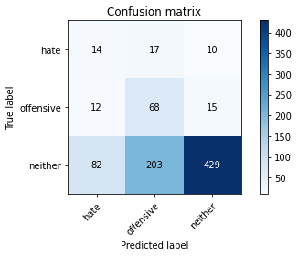

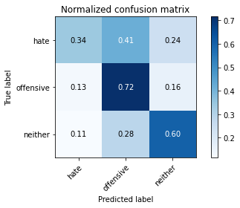

precision recall f1-score support

hate 0.13 0.34 0.19 41

offensive 0.24 0.72 0.36 95

neither 0.94 0.60 0.73 714

accuracy 0.60 850

macro avg 0.44 0.55 0.43 850

weighted avg 0.83 0.60 0.67 850

average eval_loss: 1.4407066656709757, accuracy: 0.6011764705882353

training 9 epoch...

8.975956201553345 seconds used......

9 training finished! average train loss: 0.020342320359001558

total clf loss: 0.7395137895364314 total adv loss: 0.14380518100006157

evaluating...

Confusion matrix, without normalization

[[ 10 18 13]

[ 5 56 34]

[ 38 136 540]]

Normalized confusion matrix

[[0.24390244 0.43902439 0.31707317]

[0.05263158 0.58947368 0.35789474]

[0.05322129 0.19047619 0.75630252]]

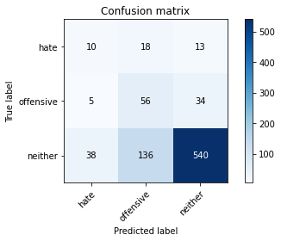

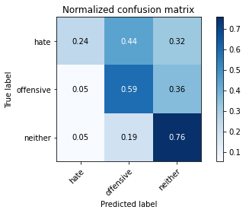

precision recall f1-score support

hate 0.19 0.24 0.21 41

offensive 0.27 0.59 0.37 95

neither 0.92 0.76 0.83 714

accuracy 0.71 850

macro avg 0.46 0.53 0.47 850

weighted avg 0.81 0.71 0.75 850

average eval_loss: 1.0811378115755614, accuracy: 0.7129411764705882

training 10 epoch...

8.927207469940186 seconds used......

10 training finished! average train loss: 0.010871848220833473

total clf loss: 0.3925530598498881 total adv loss: 0.023330489083491557

evaluating...

Confusion matrix, without normalization

[[ 11 18 12]

[ 8 65 22]

[ 58 160 496]]

Normalized confusion matrix

[[0.26829268 0.43902439 0.29268293]

[0.08421053 0.68421053 0.23157895]

[0.08123249 0.22408964 0.69467787]]

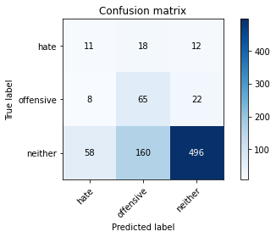

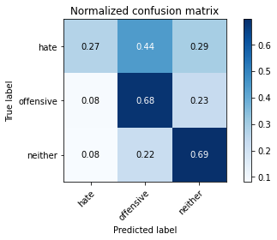

precision recall f1-score support

hate 0.14 0.27 0.19 41

offensive 0.27 0.68 0.38 95

neither 0.94 0.69 0.80 714

accuracy 0.67 850

macro avg 0.45 0.55 0.46 850

weighted avg 0.82 0.67 0.72 850

average eval_loss: 1.3082883116399306, accuracy: 0.6729411764705883

4 run......

training 1 epoch...

8.968224287033081 seconds used......

1 training finished! average train loss: 1.0229360163211823

total clf loss: 38.039324164390564 total adv loss: 24.272546470165253

evaluating...

Confusion matrix, without normalization

[[ 3 27 11]

[ 0 15 80]

[ 11 173 530]]

Normalized confusion matrix

[[0.07317073 0.65853659 0.26829268]

[0. 0.15789474 0.84210526]

[0.01540616 0.24229692 0.74229692]]

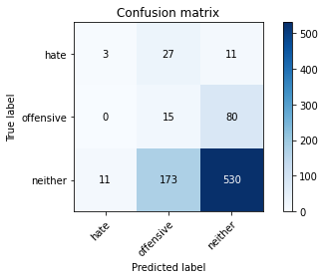

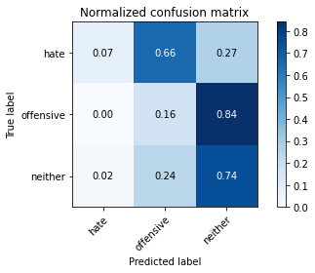

precision recall f1-score support

hate 0.21 0.07 0.11 41

offensive 0.07 0.16 0.10 95

neither 0.85 0.74 0.79 714

accuracy 0.64 850

macro avg 0.38 0.32 0.33 850

weighted avg 0.74 0.64 0.68 850

average eval_loss: 0.897769081038098, accuracy: 0.6447058823529411

training 2 epoch...

8.93075680732727 seconds used......

2 training finished! average train loss: 0.8994582858350542

total clf loss: 33.50278830528259 total adv loss: 22.445797950029373

evaluating...

Confusion matrix, without normalization

[[ 1 38 2]

[ 0 90 5]

[ 2 466 246]]

Normalized confusion matrix

[[0.02439024 0.92682927 0.04878049]

[0. 0.94736842 0.05263158]

[0.00280112 0.65266106 0.34453782]]

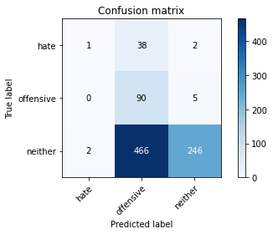

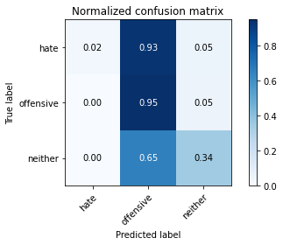

precision recall f1-score support

hate 0.33 0.02 0.05 41

offensive 0.15 0.95 0.26 95

neither 0.97 0.34 0.51 714

accuracy 0.40 850

macro avg 0.49 0.44 0.27 850

weighted avg 0.85 0.40 0.46 850

average eval_loss: 1.0272890253122462, accuracy: 0.39647058823529413

training 3 epoch...

8.913520097732544 seconds used......

3 training finished! average train loss: 0.7731712559858958

total clf loss: 28.780130684375763 total adv loss: 18.919308483600616

evaluating...

Confusion matrix, without normalization

[[ 3 32 6]

[ 4 73 18]

[ 24 247 443]]

Normalized confusion matrix

[[0.07317073 0.7804878 0.14634146]

[0.04210526 0.76842105 0.18947368]

[0.03361345 0.34593838 0.62044818]]

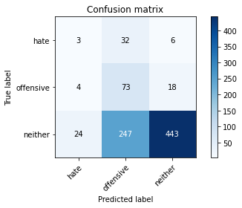

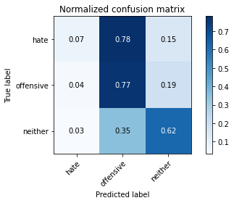

precision recall f1-score support

hate 0.10 0.07 0.08 41

offensive 0.21 0.77 0.33 95

neither 0.95 0.62 0.75 714

accuracy 0.61 850

macro avg 0.42 0.49 0.39 850

weighted avg 0.82 0.61 0.67 850

average eval_loss: 0.8204878086960593, accuracy: 0.6105882352941177

training 4 epoch...

8.954344987869263 seconds used......

4 training finished! average train loss: 0.578881825423903

total clf loss: 21.603770822286606 total adv loss: 15.28050247207284

evaluating...

Confusion matrix, without normalization

[[ 13 20 8]

[ 10 65 20]

[ 69 195 450]]

Normalized confusion matrix

[[0.31707317 0.48780488 0.19512195]

[0.10526316 0.68421053 0.21052632]

[0.09663866 0.27310924 0.6302521 ]]

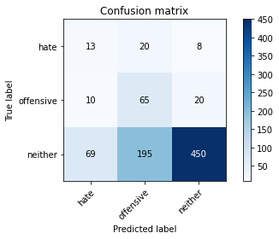

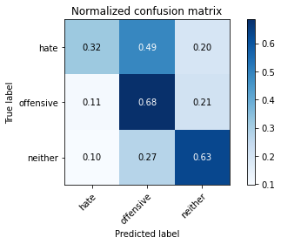

precision recall f1-score support

hate 0.14 0.32 0.20 41

offensive 0.23 0.68 0.35 95

neither 0.94 0.63 0.76 714

accuracy 0.62 850

macro avg 0.44 0.54 0.43 850

weighted avg 0.82 0.62 0.68 850

average eval_loss: 0.8238942666455756, accuracy: 0.6211764705882353

training 5 epoch...

8.934430599212646 seconds used......

5 training finished! average train loss: 0.39186646996272934

total clf loss: 14.580743074417114 total adv loss: 9.471001762896776

evaluating...

Confusion matrix, without normalization

[[ 12 22 7]

[ 10 67 18]

[ 64 220 430]]

Normalized confusion matrix

[[0.29268293 0.53658537 0.17073171]

[0.10526316 0.70526316 0.18947368]

[0.08963585 0.30812325 0.6022409 ]]

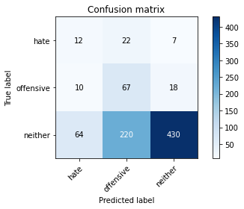

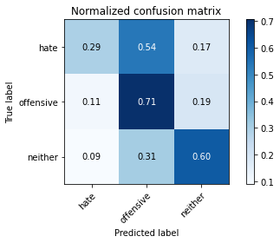

precision recall f1-score support

hate 0.14 0.29 0.19 41

offensive 0.22 0.71 0.33 95

neither 0.95 0.60 0.74 714

accuracy 0.60 850

macro avg 0.43 0.53 0.42 850

weighted avg 0.82 0.60 0.66 850

average eval_loss: 0.9421973468432593, accuracy: 0.5988235294117648

training 6 epoch...

8.96781039237976 seconds used......

6 training finished! average train loss: 0.21654407700730693

total clf loss: 8.008640177547932 total adv loss: 4.261067857965827

evaluating...

Confusion matrix, without normalization

[[ 9 18 14]

[ 7 53 35]

[ 38 156 520]]

Normalized confusion matrix

[[0.2195122 0.43902439 0.34146341]

[0.07368421 0.55789474 0.36842105]

[0.05322129 0.21848739 0.72829132]]

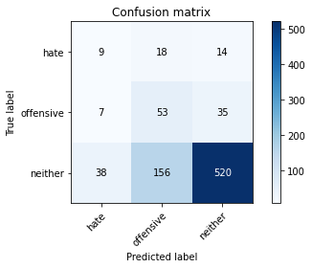

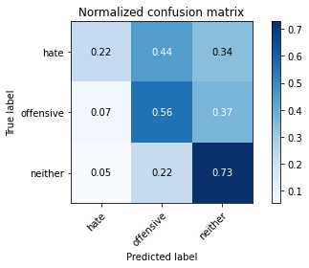

precision recall f1-score support

hate 0.17 0.22 0.19 41

offensive 0.23 0.56 0.33 95

neither 0.91 0.73 0.81 714

accuracy 0.68 850

macro avg 0.44 0.50 0.44 850

weighted avg 0.80 0.68 0.73 850

average eval_loss: 0.7867059325149586, accuracy: 0.6847058823529412

training 7 epoch...

8.93001651763916 seconds used......

7 training finished! average train loss: 0.11226193472329113

total clf loss: 4.124687220901251 total adv loss: 1.6651511632371694

evaluating...

Confusion matrix, without normalization

[[ 10 22 9]

[ 7 66 22]

[ 42 192 480]]

Normalized confusion matrix

[[0.24390244 0.53658537 0.2195122 ]

[0.07368421 0.69473684 0.23157895]

[0.05882353 0.26890756 0.67226891]]

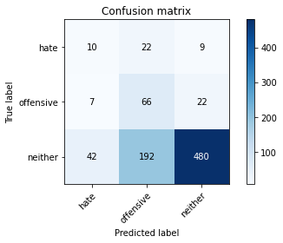

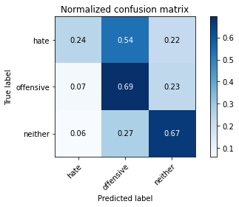

precision recall f1-score support

hate 0.17 0.24 0.20 41

offensive 0.24 0.69 0.35 95

neither 0.94 0.67 0.78 714

accuracy 0.65 850

macro avg 0.45 0.54 0.45 850

weighted avg 0.82 0.65 0.71 850

average eval_loss: 0.9762182153414848, accuracy: 0.6541176470588236

training 8 epoch...

8.93398118019104 seconds used......

8 training finished! average train loss: 0.041663517554601036

total clf loss: 1.5188911729492247 total adv loss: 0.38009078841423616

evaluating...

Confusion matrix, without normalization

[[ 10 22 9]

[ 8 77 10]

[ 39 211 464]]

Normalized confusion matrix

[[0.24390244 0.53658537 0.2195122 ]

[0.08421053 0.81052632 0.10526316]

[0.05462185 0.29551821 0.64985994]]

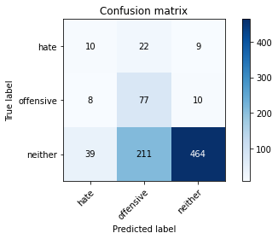

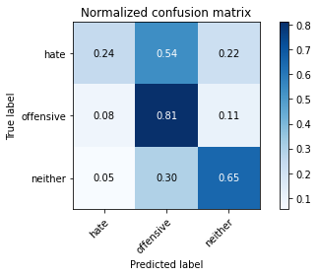

precision recall f1-score support

hate 0.18 0.24 0.20 41

offensive 0.25 0.81 0.38 95

neither 0.96 0.65 0.78 714

accuracy 0.65 850

macro avg 0.46 0.57 0.45 850

weighted avg 0.84 0.65 0.70 850

average eval_loss: 1.1743289449273846, accuracy: 0.648235294117647

training 9 epoch...

8.974565744400024 seconds used......

9 training finished! average train loss: 0.020615348488920264

total clf loss: 0.7510785823687911 total adv loss: 0.17852079641306773

evaluating...

Confusion matrix, without normalization

[[ 11 21 9]

[ 9 67 19]

[ 52 193 469]]

Normalized confusion matrix

[[0.26829268 0.51219512 0.2195122 ]

[0.09473684 0.70526316 0.2 ]

[0.07282913 0.27030812 0.65686275]]

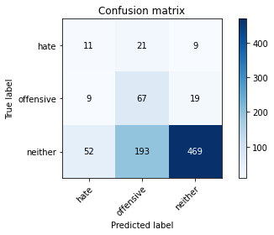

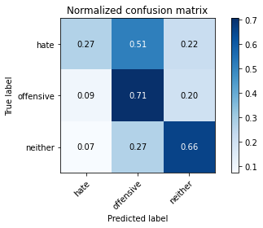

precision recall f1-score support

hate 0.15 0.27 0.19 41

offensive 0.24 0.71 0.36 95

neither 0.94 0.66 0.77 714

accuracy 0.64 850

macro avg 0.44 0.54 0.44 850

weighted avg 0.83 0.64 0.70 850

average eval_loss: 1.2158314362384899, accuracy: 0.6435294117647059

training 10 epoch...

8.908150672912598 seconds used......

10 training finished! average train loss: 0.011539415521029796

total clf loss: 0.4173279548995197 total adv loss: 0.038179909754944674

evaluating...

Confusion matrix, without normalization

[[ 10 21 10]

[ 9 72 14]

[ 51 200 463]]

Normalized confusion matrix

[[0.24390244 0.51219512 0.24390244]

[0.09473684 0.75789474 0.14736842]

[0.07142857 0.28011204 0.64845938]]

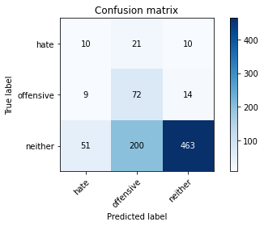

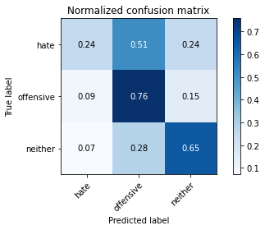

precision recall f1-score support

hate 0.14 0.24 0.18 41

offensive 0.25 0.76 0.37 95

neither 0.95 0.65 0.77 714

accuracy 0.64 850

macro avg 0.45 0.55 0.44 850

weighted avg 0.83 0.64 0.70 850

average eval_loss: 1.3235146188675317, accuracy: 0.6411764705882353

5 run......

training 1 epoch...

8.994439125061035 seconds used......

1 training finished! average train loss: 1.0539134972625308

total clf loss: 39.13497120141983 total adv loss: 23.88170897960663

evaluating...

Confusion matrix, without normalization

[[ 0 41 0]

[ 0 95 0]

[ 0 649 65]]

Normalized confusion matrix

[[0. 1. 0. ]

[0. 1. 0. ]

[0. 0.90896359 0.09103641]]

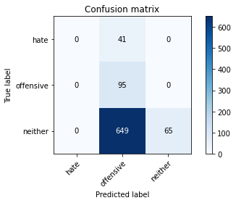

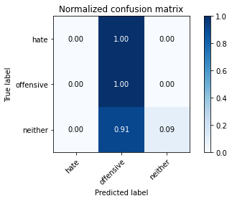

/opt/conda/lib/python3.7/site-packages/sklearn/metrics/_classification.py:1245: UndefinedMetricWarning: Precision and F-score are ill-defined and being set to 0.0 in labels with no predicted samples. Use `zero_division` parameter to control this behavior.

_warn_prf(average, modifier, msg_start, len(result))

/opt/conda/lib/python3.7/site-packages/sklearn/metrics/_classification.py:1245: UndefinedMetricWarning: Precision and F-score are ill-defined and being set to 0.0 in labels with no predicted samples. Use `zero_division` parameter to control this behavior.

_warn_prf(average, modifier, msg_start, len(result))

/opt/conda/lib/python3.7/site-packages/sklearn/metrics/_classification.py:1245: UndefinedMetricWarning: Precision and F-score are ill-defined and being set to 0.0 in labels with no predicted samples. Use `zero_division` parameter to control this behavior.

_warn_prf(average, modifier, msg_start, len(result))

precision recall f1-score support

hate 0.00 0.00 0.00 41

offensive 0.12 1.00 0.22 95

neither 1.00 0.09 0.17 714

accuracy 0.19 850

macro avg 0.37 0.36 0.13 850

weighted avg 0.85 0.19 0.16 850

average eval_loss: 1.1183650784714276, accuracy: 0.18823529411764706

training 2 epoch...

8.933763980865479 seconds used......

2 training finished! average train loss: 0.9052976121505102

total clf loss: 33.656085789203644 total adv loss: 21.30743333697319

evaluating...

Confusion matrix, without normalization

[[ 9 27 5]

[ 4 60 31]

[ 31 231 452]]

Normalized confusion matrix

[[0.2195122 0.65853659 0.12195122]

[0.04210526 0.63157895 0.32631579]

[0.04341737 0.32352941 0.63305322]]

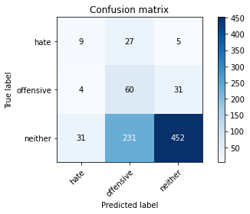

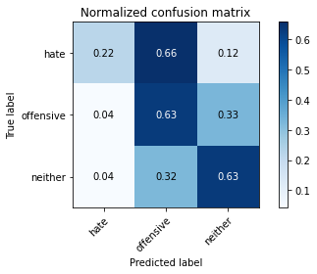

precision recall f1-score support

hate 0.20 0.22 0.21 41

offensive 0.19 0.63 0.29 95

neither 0.93 0.63 0.75 714

accuracy 0.61 850

macro avg 0.44 0.49 0.42 850

weighted avg 0.81 0.61 0.67 850

average eval_loss: 0.8986726226501687, accuracy: 0.6129411764705882

training 3 epoch...

8.92712688446045 seconds used......

3 training finished! average train loss: 0.7739261405335532

total clf loss: 28.8869007229805 total adv loss: 20.511194616556168

evaluating...

Confusion matrix, without normalization

[[ 3 18 20]

[ 2 33 60]

[ 10 99 605]]

Normalized confusion matrix

[[0.07317073 0.43902439 0.48780488]

[0.02105263 0.34736842 0.63157895]

[0.0140056 0.13865546 0.84733894]]

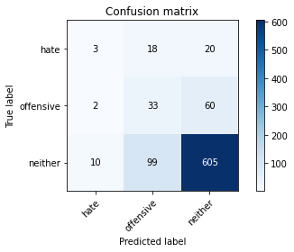

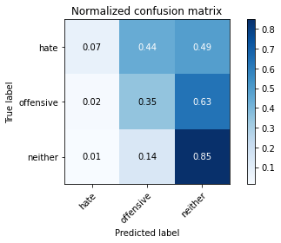

precision recall f1-score support

hate 0.20 0.07 0.11 41

offensive 0.22 0.35 0.27 95

neither 0.88 0.85 0.86 714

accuracy 0.75 850

macro avg 0.43 0.42 0.41 850

weighted avg 0.78 0.75 0.76 850

average eval_loss: 0.6158746891590052, accuracy: 0.7541176470588236

training 4 epoch...

8.968771934509277 seconds used......

4 training finished! average train loss: 0.5750960947738754

total clf loss: 21.50973755121231 total adv loss: 16.125561237335205

evaluating...

Confusion matrix, without normalization

[[ 6 22 13]

[ 2 64 29]

[ 24 175 515]]

Normalized confusion matrix

[[0.14634146 0.53658537 0.31707317]

[0.02105263 0.67368421 0.30526316]

[0.03361345 0.24509804 0.72128852]]

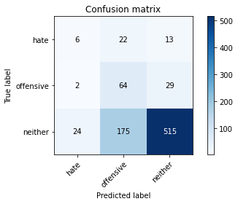

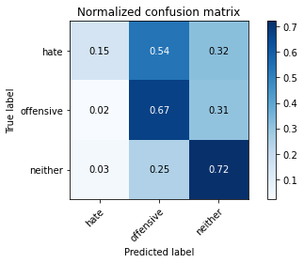

precision recall f1-score support

hate 0.19 0.15 0.16 41

offensive 0.25 0.67 0.36 95

neither 0.92 0.72 0.81 714

accuracy 0.69 850

macro avg 0.45 0.51 0.44 850

weighted avg 0.81 0.69 0.73 850

average eval_loss: 0.7042307756667914, accuracy: 0.6882352941176471

training 5 epoch...

8.923983335494995 seconds used......

5 training finished! average train loss: 0.4224829549590747

total clf loss: 15.78944580256939 total adv loss: 11.601187497377396

evaluating...

Confusion matrix, without normalization

[[ 17 17 7]

[ 20 60 15]

[ 88 201 425]]

Normalized confusion matrix

[[0.41463415 0.41463415 0.17073171]

[0.21052632 0.63157895 0.15789474]

[0.1232493 0.28151261 0.5952381 ]]

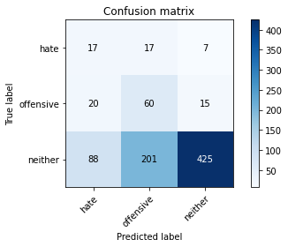

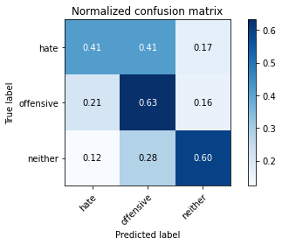

precision recall f1-score support

hate 0.14 0.41 0.20 41

offensive 0.22 0.63 0.32 95

neither 0.95 0.60 0.73 714

accuracy 0.59 850

macro avg 0.43 0.55 0.42 850

weighted avg 0.83 0.59 0.66 850

average eval_loss: 0.9261363733473212, accuracy: 0.5905882352941176

training 6 epoch...

9.012545585632324 seconds used......

6 training finished! average train loss: 0.21336021977994177

total clf loss: 7.918312571942806 total adv loss: 4.746892841532826

evaluating...

Confusion matrix, without normalization

[[ 16 9 16]

[ 15 42 38]

[ 60 127 527]]

Normalized confusion matrix

[[0.3902439 0.2195122 0.3902439 ]

[0.15789474 0.44210526 0.4 ]

[0.08403361 0.17787115 0.73809524]]

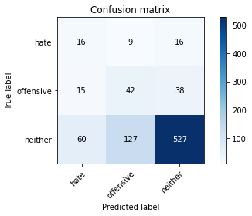

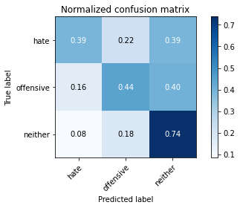

precision recall f1-score support

hate 0.18 0.39 0.24 41

offensive 0.24 0.44 0.31 95

neither 0.91 0.74 0.81 714

accuracy 0.69 850

macro avg 0.44 0.52 0.45 850

weighted avg 0.80 0.69 0.73 850

average eval_loss: 0.7772046030867238, accuracy: 0.6882352941176471

training 7 epoch...

8.94119644165039 seconds used......

7 training finished! average train loss: 0.09653673134744167

total clf loss: 3.5487478710711002 total adv loss: 1.4685104075470008

evaluating...

Confusion matrix, without normalization

[[ 15 14 12]

[ 9 60 26]

[ 51 184 479]]

Normalized confusion matrix

[[0.36585366 0.34146341 0.29268293]

[0.09473684 0.63157895 0.27368421]

[0.07142857 0.25770308 0.67086835]]

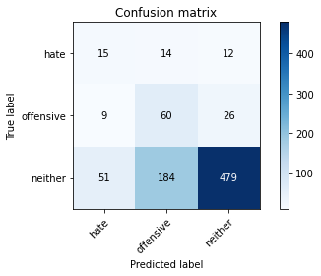

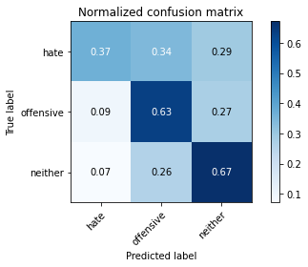

precision recall f1-score support

hate 0.20 0.37 0.26 41

offensive 0.23 0.63 0.34 95

neither 0.93 0.67 0.78 714

accuracy 0.65 850

macro avg 0.45 0.56 0.46 850

weighted avg 0.81 0.65 0.70 850

average eval_loss: 1.020665596022682, accuracy: 0.6517647058823529

training 8 epoch...

8.933388233184814 seconds used......

8 training finished! average train loss: 0.05074260583043926

total clf loss: 1.8430864419788122 total adv loss: 0.3270523896499071

evaluating...

Confusion matrix, without normalization

[[ 17 8 16]

[ 11 42 42]

[ 48 130 536]]

Normalized confusion matrix

[[0.41463415 0.19512195 0.3902439 ]

[0.11578947 0.44210526 0.44210526]

[0.06722689 0.18207283 0.75070028]]

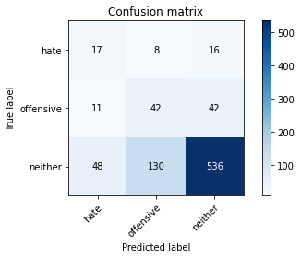

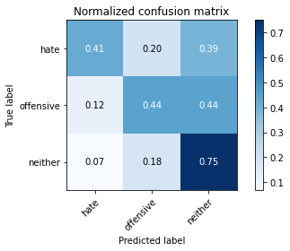

precision recall f1-score support

hate 0.22 0.41 0.29 41

offensive 0.23 0.44 0.31 95

neither 0.90 0.75 0.82 714

accuracy 0.70 850

macro avg 0.45 0.54 0.47 850

weighted avg 0.79 0.70 0.74 850

average eval_loss: 0.9382574139271191, accuracy: 0.7

training 9 epoch...

8.976334571838379 seconds used......

9 training finished! average train loss: 0.04896429322090828

total clf loss: 1.7704174644313753 total adv loss: 0.1540582220768556

evaluating...

Confusion matrix, without normalization

[[ 13 14 14]

[ 12 51 32]

[ 56 146 512]]

Normalized confusion matrix

[[0.31707317 0.34146341 0.34146341]

[0.12631579 0.53684211 0.33684211]

[0.07843137 0.20448179 0.71708683]]

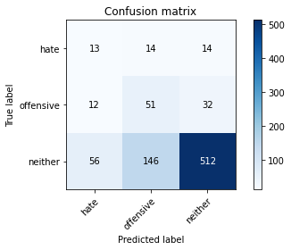

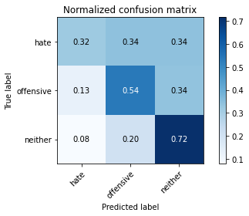

precision recall f1-score support

hate 0.16 0.32 0.21 41

offensive 0.24 0.54 0.33 95

neither 0.92 0.72 0.81 714

accuracy 0.68 850

macro avg 0.44 0.52 0.45 850

weighted avg 0.81 0.68 0.72 850

average eval_loss: 1.039024402441587, accuracy: 0.6776470588235294

training 10 epoch...

8.934190034866333 seconds used......

10 training finished! average train loss: 0.013918495232549807

total clf loss: 0.5057492800988257 total adv loss: 0.0936690675553109

evaluating...

Confusion matrix, without normalization

[[ 14 14 13]

[ 13 57 25]

[ 56 172 486]]

Normalized confusion matrix

[[0.34146341 0.34146341 0.31707317]

[0.13684211 0.6 0.26315789]

[0.07843137 0.24089636 0.68067227]]

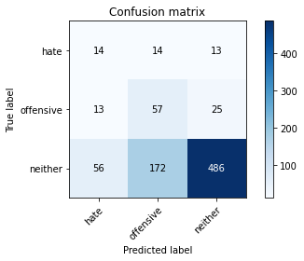

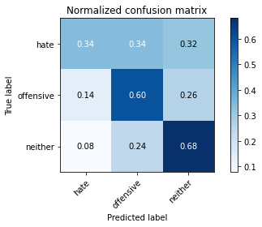

precision recall f1-score support

hate 0.17 0.34 0.23 41

offensive 0.23 0.60 0.34 95

neither 0.93 0.68 0.79 714

accuracy 0.66 850

macro avg 0.44 0.54 0.45 850

weighted avg 0.81 0.66 0.71 850

average eval_loss: 1.235124098981709, accuracy: 0.6552941176470588